Technical Architecture of Interoperable QR Code Instant Money Transfers

1. QR Code Generation Architecture

Components
- Payment Identifier
  - Unique Virtual Payment Address (VPA)
  - Typically in format: username@bankcode
  - Abstracts actual bank account details
  - Enables privacy and simplified addressing

QR Code Payload Structure
{
"paymentAddress": "john.doe@bankx",
"merchantId": "MERCHANT123",
"amount": 500.00,
"currency": "INR",
"purpose": "Retail Purchase",
"transactionId": "TXN20240326123456",
"expiryTimestamp": "2024-03-26T23:59:59Z"
}

2. Technical Verification Layers

2.1 Cryptographic Validation
- Digital Signature Verification
- Payload Integrity Check
- Timestamp Validation
- Anti-Replay Mechanism

2.2 Routing Mechanisms
- Routing Information Service (RIS)
  - Maps Virtual Payment Addresses to Bank Identifiers
  - Maintains Real-Time Routing Tables
  - Supports Multi-Bank, Multi-Provider Ecosystem

3. Instant Transfer Protocol
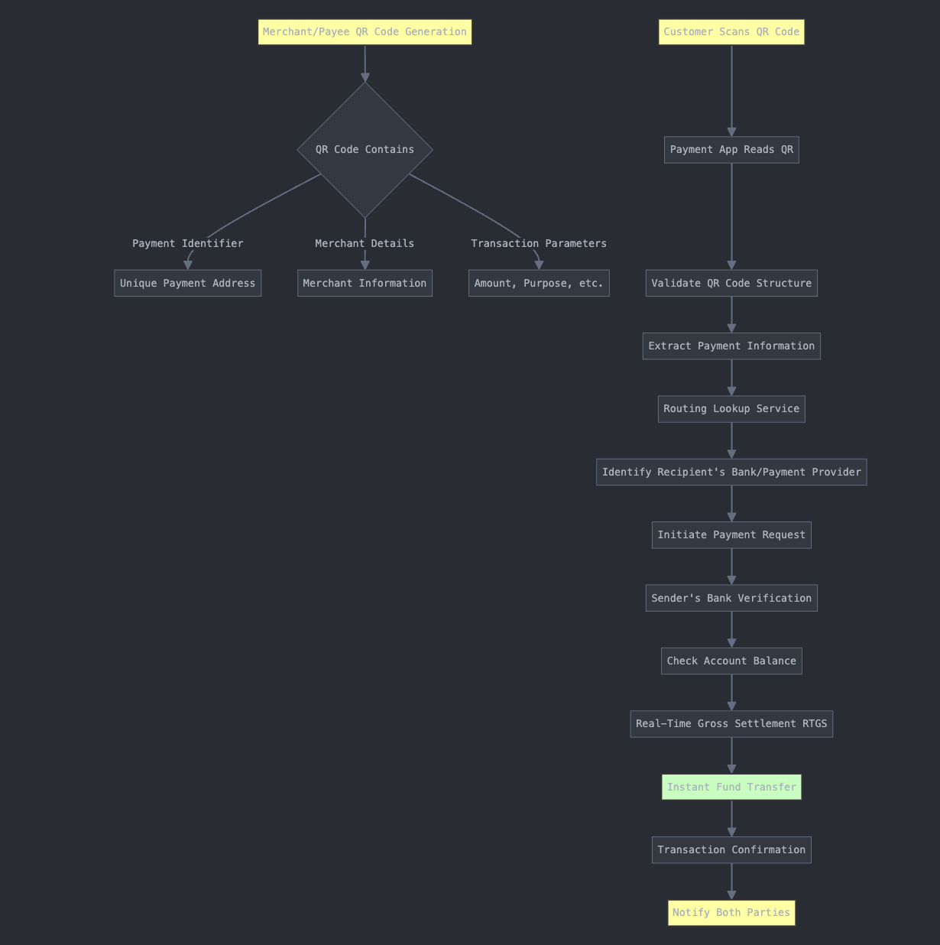

Transfer Steps
- QR Code Scan
- Payment Address Extraction
- Bank/Provider Routing
- Account Validation
- Fund Transfer Authorization
- Instant Settlement
- Cryptographic Confirmation

4. Security Considerations

Authentication Layers
- Multi-Factor Authentication
- Biometric Verification
- Transaction Risk Scoring
- Device Fingerprinting

Encryption Standards
- End-to-End Encryption
- TLS 1.3
- AES-256 Payload Encryption
- Public Key Infrastructure (PKI)

5. Error Handling and Resilience

Failure Scenarios
- Invalid QR Code
- Insufficient Funds
- Network Interruption
- Authentication Failure

Resilience Mechanisms
- Retry Workflows
- Rollback Transactions
- Comprehensive Logging
- Asynchronous Processing

6. Performance Optimization

Architectural Optimizations
- Distributed Caching
- Horizontal Scaling
- Edge Computing
- Microservices Architecture

Latency Targets
- Transaction Processing: <500ms
- End-to-End Transfer: <2 seconds

7. Compliance and Governance

Regulatory Compliance
- PCI DSS
- AML/KYC Regulations
- Data Localization Requirements
- Privacy Protection Standards

Audit Trail
- Immutable Transaction Logs
- Blockchain-Based Verification
- Comprehensive Metadata Capture

